**Health Connect: Streamlined Doctors Appointment and Health Record Management**

**General Description:**

Health Connect is an advanced and comprehensive platform designed to streamline doctors and health record management in the healthcare industry. It serves as a centralized system that connects healthcare professionals, patients, and health data, facilitating more efficient and effective healthcare delivery.

The primary goal of Health Connect is to improve patient outcomes and enhance the overall healthcare experience for both providers and patients.

By streamlining doctors and health record management, Health Connect aims to optimize healthcare delivery, improve patient outcomes, and enhance the overall patient experience while maintaining a high level of data security and privacy. It empowers healthcare providers to focus more on patient care and less on administrative tasks, ultimately leading to a more efficient and effective healthcare system.

**Novelty/Uniqueness:**

"Health Connect" is a platform that would likely aim to facilitate better communication and coordination among healthcare providers, patients, and health records.

**Doctor Communication and Collaboration:** Health Connect would offer a digital platform where doctors and other healthcare professionals can easily communicate and collaborate on patient care. This could involve secure messaging, video conferencing, or other tools to enable real-time discussions and consultations.

**Virtual Meeting Platform:** Health connect providers often use secure and video conferencing platforms for telehealth appointments to protect patient privacy and ensure data security. A virtual meeting with doctors, also known as a telehealth or telemedicine appointment, refers to a medical consultation conducted remotely using video conferencing technology. This type of appointment allows patients to connect with their healthcare providers without being physically present in the same location, making it a convenient and accessible option for many individuals.

**Patient Health Record Management**: The platform would centralize and securely store patient health records in electronic format. This would include medical history, diagnoses, treatments, medications, test results, and other relevant information. Having all this data accessible in one place can help healthcare providers make informed decisions about patient care.

**Data Security and Privacy**: As health information is sensitive and protected by strict privacy regulations, Health Connect would need to adhere to robust security standards to ensure patient data remains confidential and secure.

**Patient Access and Involvement**: Depending on the platform's features, patients may have access to their health records through a patient portal. They could view test results, appointment schedules, and communicate with their healthcare providers. Involving patients in their care can lead to better health outcomes and improved patient satisfaction.

**Video Connect**: Video Connect allows patients to have virtual appointments with their healthcare providers, such as doctors, specialists, therapists, or counsellors. This technology enables real-time face-to-face interactions, allowing patients to discuss their health concerns, receive medical advice, and even receive prescriptions when appropriate. This will help doctors to identify the problems of patients by their symptoms and can prescribe the medicine easily.

**Speech to text**: Speech-to-text technology can be incredibly beneficial for illiterate individuals as it allows them to communicate, access information, and interact with digital content without needing to read or write. This technology converts spoken language into written text, making it accessible and usable for people who may not be able to read or write effectively. Speech-to-text technology can bridge the communication and information gap for illiterate individuals, empowering them to participate more actively in health connect.

**Prescriptions and Follow-Up**: If medications are required, the doctor can electronically send the prescription to the patient's preferred pharmacy. They may also schedule a follow-up virtual appointment to monitor the patient's progress or discuss test results.

**Emergency shaking technology:** If someone is experiencing shaking during an emergency situation, it could be a sign of various medical or non-medical issues. It's essential to respond appropriately and seek appropriate medical attention if necessary

**Health Bot:** Health Bot refers to a software application or AI-powered chatbot designed specifically for healthcare-related purposes. It combines the capabilities of artificial intelligence (AI), natural language processing (NLP), and machine learning to provide healthcare information, answer medical queries, and offer basic healthcare assistance to users.

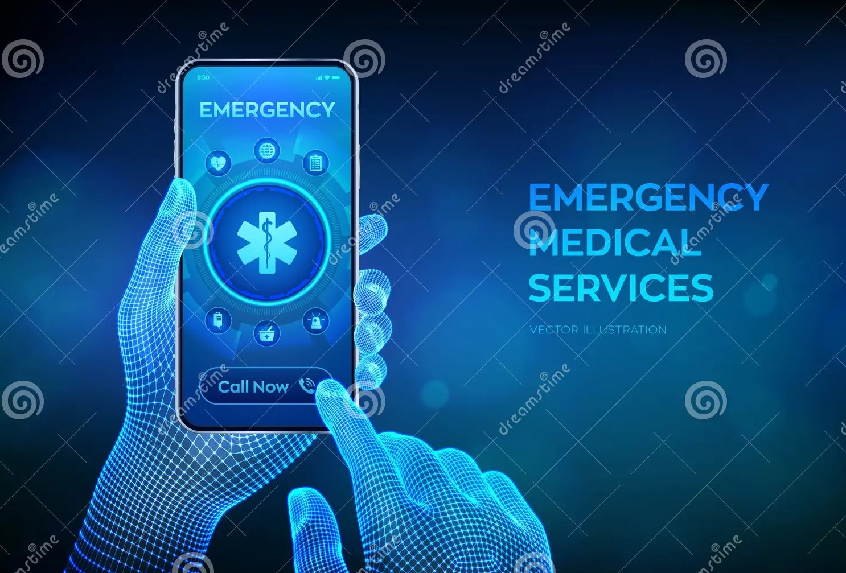

**Business/Social Impact:**

The implementation of Health Connect or similar streamlined healthcare platforms can have several positive business impacts on healthcare organizations, providers, and patients. Health Connect: streamlined doctors and health record management platform can have several positive social impacts on individuals, communities, and society as a whole. Here are some of the key business benefits:

* Improved Efficiency
* Enhanced Care Coordination
* Increased Patient Satisfaction
* Improved Patient Outcomes
* Cost Savings
* Population Health Management
* Reduced travel time and costs for patients.
* Convenient access to healthcare, especially for individuals in remote or underserved areas.
* Enhanced Health Literacy
* Health Equity
* Sustainable Healthcare Systems

It is a business regarded to unemployed doctors and profit for project developers and also feasible availability to patients.

**Technology Architecture:** Developing a Health Connect platform with a focus on streamlined doctors and health record management requires a comprehensive technology architecture that promotes efficiency, data security, and seamless integration. Here's a high-level overview of the technology architecture**:**

* **Python**
* **Angular**
* **Node.js**
* **Oracle SQL database**
* **Cloud-Based Infrastructure**
* **Electronic Health Record (EHR) System**
* **Mobile Applications**
* **User Interfaces**
* **Telemedicine Integration**
* **Front-end development**
* **Back-end development**

**Scope of work:**

The scope of work for a project involving the development and implementation of a Health Connect platform with a focus on streamlined doctors and health record management would typically include a range of activities and deliverables. Here is an outline of the scope of work:

* Project Planning and Analysis
* Technology Architecture and Design
* Development and Integration
* Data Security and Compliance
* AI and Analytics
* Testing and Quality Assurance
* Training and Documentation
* Deployment and Go-Live
* Support and Maintenance
* Project Management and Communication